Privilege Escalation and Persistence Lab

Steps:
Start with gaining shell with help of an exploit etc.
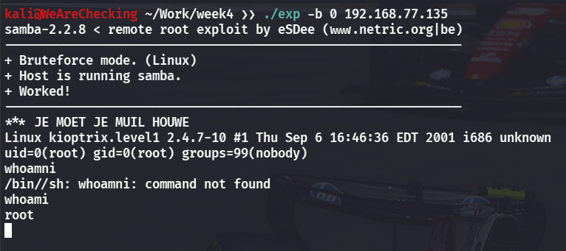

Start a python server on our machine to transfer files.
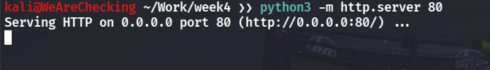

Use wget to transfer Linpeas to our machine.
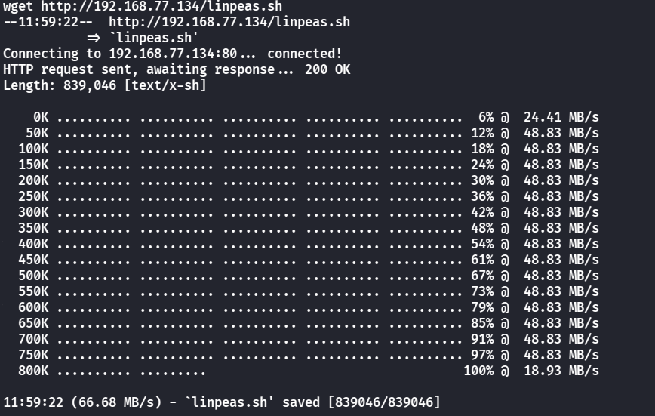

Linpeas
Running Linpeas on target machine:
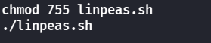

SUID present on target machine:
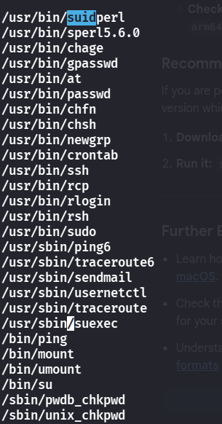

Setting up Persistence
Use echo to add a cronjob to /etc/crontab file to get a reverse shell every 5 minutes for persistence.

Checking our cron file:
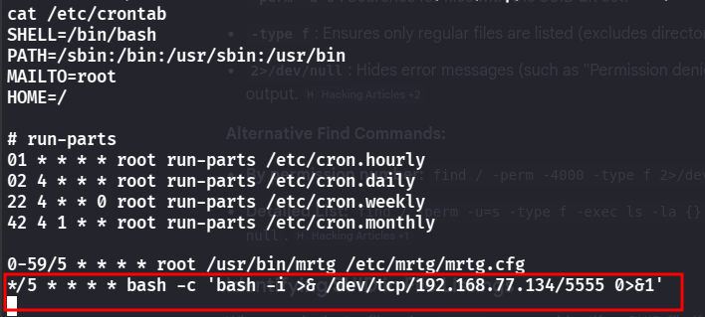

Run netcat on our machine to catch the reverse shell.
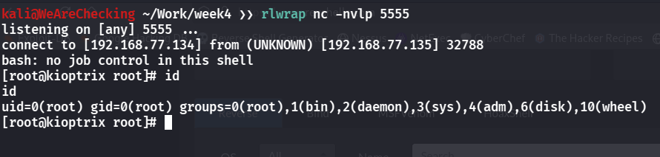

Summary of persistence method
Create a cron job by editing crontab or piping a command into crontab. Add a scheduled task (e.g., every 5 minutes or @reboot) to execute a script or command, ensuring persistence. Use full paths, make scripts executable, and verify with crontab. This maintains recurring or reboot-triggered access on Linux systems.

